**Project proposal:**

***Social health and well-being in urban neighborhoods in Chicago***

1. **Study background**

Over the recent decades, environmental public health discourses evolved from an emphasis on risk factors to a broader view that includes the potential health benefits of nature (Shanahan et al., 2015). There has been increasing evidence on the positive impact of urban green space on the physical, mental, and social well-being of urban populations (Branas et al., 2011; M. C. Kondo et al., 2018; South et al., 2015; Thompson et al., 2013). This shift ultimately resulted in City-led nature-based solutions for addressing urban health problems. One of these examples is an urban greening policy in high-vacancy neighborhoods. Such neighborhoods generally have unequal access to urban nature, with less vegetation cover, public parks, green spaces, and other recreational settings (Boone et al., 2009; Rigolon, 2016; Tooke et al., 2010).

While the effect of greening is more important and stronger for underserved communities than those of higher socioeconomic status (South et al., 2018), urban greening has its paradoxical effects such as gentrification (Wolch et al., 2014). For example, constructing new parks and other green spaces can lead to uneven development transforming a low-value neighborhood into a high-value one, resulting in a dislocation of existing residents (Mullenbach & Baker, 2018). The forced displacement may cause considerable mental health problems such as emotional distress (Lim et al., 2017). To go beyond merely making cities ‘just green enough’ (Wolch et al., 2014), small-scale, bottom-up urban greening projects have been emerged and highlighted for engaging residents in decision making process and provide the most health benefits equally across neighborhoods (Flax et al., 2020; Sampson et al., 2017; Wolch et al., 2014).

1. **Purpose of the study**

The purpose of this study is to assess public health benefits and outcomes of the resident-led urban greening program called Chicago’s Large Lot Program. The Large Lot Program was first launched in 2014 to encourage residents in highly vacant areas who own property on the same block as the vacant lots to purchase up to two lots for a dollar per lot. The Large Lot owners have obligations to maintain the property, including paying property taxes and installing a fence (City of Chicago, 2020). Some creative owners further used their private lots as public spaces, providing community spaces such as a playground and a community garden (Jeong et al., 2021). These visual signs of landscape care have important social health implications as the overall impression of the landscape would affect others’ assumptions about the people who live in the area (Nassauer, 2011). Wilson and Kelling’s (1982) broken windows theory also described that physical signs of neglect and disorder can encourage further crime and anti-social behaviors in the neighborhood, negatively affecting residents’ feelings of well-being and safety.

The previous studies on the impacts of Chicago’s policy aligned with many positive outcomes, including improvement in condition and care of purchased vacant lots across time (Gobster, Hadavi, et al., 2020; Gobster, Rigolon, et al., 2020), increased senses of place and community (Stewart et al., 2019), increased efficacy to beautify the block (Jeong et al., 2021), and reduction in some types of crime on blocks containing purchased lots (Hadavi et al., in press). Given the lack of research on the public health literature, this study will take further steps to evaluate Chicago’s Large Lot Program within an urban health policy context. The proposed research questions include the following:

1. To what extent is urban vacancy associated with health outcomes in Chicago?
2. To what extent is the Large Lot Program associated with better social health outcomes?
3. **Study sites**

The five community areas selected for study sites are East Garfield Park, Englewood, West Englewood, Washington Park, and Woodlawn in Chicago (Figure 1).

**Figure 1.** Study sites (left) and vacant lots sold through the Large Lot Program (right)

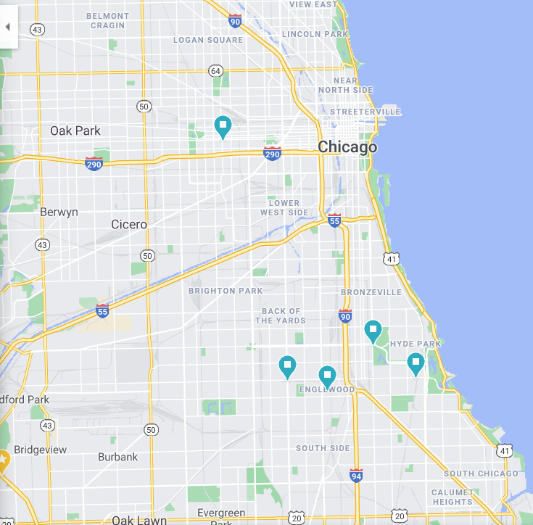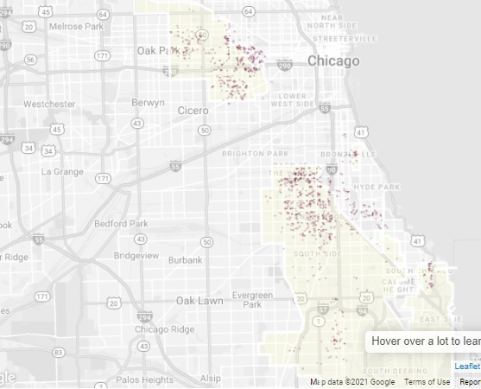

Sources: Google map, The City of Chicago (<https://largelots.org/>)

1. **Scales and measurements**
2. I will conduct block-level analyses derived from U.S. Census block groups.
3. For demographic analyses, U.S. consensus data will be used.
4. The health outcomes are directed at concepts related to neighborhood physical disorder, perceived health status, mental distress, neighborhood satisfaction, social cohesion, and sense of safety.
5. The study will be based on a survey conducted in 2016-2018 and 2020 by the Chicago Department of Public Health (CDPH). The questionnaire included mostly closed-ended 113 questions about the health of people in their neighborhood. The questions only related to the concepts stated in (c) will be used for data analyses.
6. **Research questions and strategies for analyses**

***Question 1: To what extent is urban vacancy associated with health outcomes in Chicago?***

While dominant negative stereotypes of high-vacancy neighborhoods are common across cultures (e.g., Jin et al., 2021), urban vacancy issues in an American context are built upon the long history of racial isolation, discrimination, and poverty issues. The residents living near the vacant lots are often racial and ethnic minorities (Shinew et al., 2004; White, 2011); in Chicago, similarly, the high-vacancy areas are characterized by predominantly African American, lower-income neighborhoods (Iverson & Cook, 2000; Stewart et al., 2019). These neighborhoods suffer from undesirable behaviors in nearby vacant lots such as dumping, littering, and many other criminal activities which are threats to the neighborhood’s health and safety (Garvin et al., 2013).

Given this background, the study will investigate whether urban vacancy is associated with health outcomes in Chicago. The demographic analysis will be conducted in advance to understand demographic aspects of the high-vacancy urban neighborhoods in Chicago, including age, race, income, and educational background. Some tables will be presented to highlight how demographic data in vacant urban neighborhoods differ from overall Chicago’s populations. Data related to subjective well-being indicators (perceived health status, mental distress, neighborhood satisfaction, and sense of safety) will present how healthy the neighborhoods with high vacancy rates are compared to other neighborhoods with lower vacancy rates.

***Question 2: To what extent is the Large Lot Program associated with better social health outcomes?***

Vacant lot greening strategies have contributed to the positive changes in urban neighborhoods’ health and well-being, reducing crimes (Branas et al., 2011; Kondo et al., 2016), increasing perceptions of safety among residents (Garvin et al., 2012; Jin et al., 2021; Sampson et al., 2017), and reduction in feeling depressed and worthless (South et al., 2018). Social cohesion is another relevant concept related to a social determinant of health that involves feelings of belonging, connectedness, trust, and other social interactions through the shared aims and values (Jennings & Bamkole, 2019). While social cohesion and its impact on health have been largely studied in the context of community gardens (e.g., Yotti Kingsley & Townsend, 2006) rather than home-based green spaces that are the most cases of Large Lot Program, Pollard et al. (2018) described how home gardeners also interact with the broader community and contribute to the social well-being. As described by Jeong et al. (2021), Chicago’s Large Lot owners also intended the public use of their private lots, which can encourage more social interactions, and thus, develop higher levels of social cohesion in their neighborhoods.

The study hypothesizes that enhancing the social environment would affect the neighborhood’s perceptions of safety and well-being (Foo et al., 2015). To understand the impact of Chicago’s Large Lot Program on the interpersonal dynamics of residents, social determinants of health (social cohesion, social relationship, social support, empowerment) will be specifically examined. Other health-related variables for data analyses include perceived health status, mental distress, neighborhood satisfaction, and sense of safety. If possible, I will also examine whether there is a statistically significant relationship between social determinants and health in the targeting neighborhoods.

1. **Target audience**

I expect this work to be presented to the CDPH as well as a wider audience of residents in Chicago who will participate in focus groups for my future study. The study will provide health implications of resident-based private ownership of vacant land for city governments. By examining the long-term effects of Chicago’s Large Lor Program on neighborhood health and well-being, this study will lend support to urban greening policies that largely depend on residential participation. Further, study findings will be aligned with the Heathy Chicago goals and strategies to address structural health and racial inequities in Chicago (Chicago Department of Public Health, 2020). Taken together, it will support the idea that municipalities that integrate broader social factors in their public health strategies could promote neighborhood health and safety.

1. **Study limitations and questions**
2. The purpose of this project is not for complete and perfect analyses to publish, but for 1) developing background knowledge for my prospectus and 2) familiarizing myself with the CDPH dataset and conducting exploratory analyses.
3. One possible issue is data availability since it can take more time for our research team to access the 2016-18 and the upcoming 2020 dataset of a survey by the CDPH. The CDPH is currently working on de-identifying and cleaning data for sharing the data. I will have access to it only after this process. If the dataset is not available until March, I will be most likely to use publicly available data (<https://www.chicagohealthatlas.org/>) and may revise research questions after consultation with Professor Greenlee.
4. The sample size of the CDPH dataset in targeting areas may not be large enough to do analyses due to the low response rates. Accordingly, analytical approaches will largely depend on data availability, and I will have a careful examination of data to acknowledge some limitations before starting data analyses.
5. Due to the uncertainty of types of data, the research questions are not yet specific enough. In general, I am interested in understanding the social environment (e.g., social cohesion, social support, social relationship) of the high-vacancy neighborhoods in Chicago and how these social components positively and/or negatively affect their health and well-being.
6. The second research question about evaluating Chicago’s Large Lot Program can be difficult to answer, as data may not be comparable with past data. Also, while it would be ideal to analyze between 2013 (before the Large Lot Program) and 2020 to understand the neighborhood change over time and evaluate the health benefits of the Large Lot Program, the available dataset is only for 2016-18 and 2020. This is a major limitation of this portion of the study and should be expressed as such.
7. As a question, I wondered what kinds of data visualization will be the most effective for the project. I would appreciate it if you (or other classmates) could provide more examples of visualized data at the neighborhood-level.

**References**

Boone, C. G., Buckley, G. L., Grove, J. M., & Sister, C. (2009). Parks and people: An environmental justice inquiry in Baltimore, Maryland. *Annals of the Association of American Geographers*, *99*(4), 767–787. https://doi.org/10.1080/00045600903102949

Branas, C. C., Cheney, R. A., MacDonald, J. M., Tam, V. W., Jackson, T. D., & Ten Havey, T. R. (2011). A difference-in-differences analysis of health, safety, and greening vacant urban space. *American Journal of Epidemiology*, *174*(11), 1296–1306. https://doi.org/10.1093/aje/kwr273

Chicago Department of Public Health. (2020). *Healthy Chicago 2025*.

City of Chicago. (2020). *$1 Large Lots*. https://largelots.org/

Flax, L., Korthals Altes, R., Kupers, R., & Mons, B. (2020). Greening schoolyards - An urban resilience perspective. *Cities*, *106*(June), 102890. https://doi.org/10.1016/j.cities.2020.102890

Foo, K., Martin, D., Polsky, C., Wool, C., & Ziemer, M. (2015). Social well-being and environmental governance in urban neighbourhoods in Boston, MA. *Geographical Journal*, *181*(2), 138–146. https://doi.org/10.1111/geoj.12108

Garvin, E., Branas, C., Keddem, S., Sellman, J., & Cannuscio, C. (2013). More than just an eyesore: Local insights and solutions on vacant land and urban health. *Journal of Urban Health*, *90*(3), 412–426. https://doi.org/10.1007/s11524-012-9782-7

Garvin, E. C., Cannuscio, C. C., & Branas, C. C. (2012). Greening vacant lots to reduce violent crime: A randomised controlled trial. *Injury Prevention*, *19*(3), 198–203. https://doi.org/10.1136/injuryprev-2012-040439

Gobster, P. H., Hadavi, S., Rigolon, A., & Stewart, W. P. (2020). Measuring landscape change, lot by lot: Greening activity in response to a vacant land reuse program. *Landscape and Urban Planning*, *196*(103729), 1–11. https://doi.org/10.1016/j.landurbplan.2019.103729

Gobster, P. H., Rigolon, A., Hadavi, S., & Stewart, W. P. (2020). The condition-care scale: A practical approach to monitoring progress in vacant lot stewardship programs. *Landscape and Urban Planning*, *203*(June), 103885. https://doi.org/10.1016/j.landurbplan.2020.103885

Hadavi, S., Gobster, P. H., Rigolon, A., & Stewart, W. (n.d.). Crime in residential blocks: Does greening vacant Lots matter? *Landscape and Urban Planning*.

Iverson, L., & Cook, E. (2000). Urban forest cover of the Chicago region and its relation to household density and income. *Urban Ecosystems*, *4*(2), 105–124. https://doi.org/10.1023/A:1011307327314

Jennings, V., & Bamkole, O. (2019). The relationship between social cohesion and urban green space: An avenue for health promotion. *International Journal of Environmental Research and Public Health*, *16*(3). https://doi.org/10.3390/ijerph16030452

Jeong, W., Stewart, W. P., Gobster, P. H., & van Riper, C. J. (2021). Green Leisure: Resistance and Revitalization of Urban Neighborhoods. *Leisure Sciences*, 1–21. https://doi.org/10.1080/01490400.2021.1889422

Jin, H. Y., Kwon, Y., Yoo, S., Yim, D. H., & Han, S. (2021). Can urban greening using abandoned places promote citizens’ wellbeing? Case in Daegu City, South Korea. *Urban Forestry and Urban Greening*, *57*(November 2020), 126956. https://doi.org/10.1016/j.ufug.2020.126956

Kondo, M. C., Fluehr, J. M., McKeon, T., & Branas, C. C. (2018). Urban green space and its impact on human health. *International Journal of Environmental Research and Public Health*, *15*(3). https://doi.org/10.3390/ijerph15030445

Kondo, M., Hohl, B., Han, S. H., & Branas, C. (2016). Effects of greening and community reuse of vacant lots on crime. *Urban Studies*, *53*(15), 3279–3295. https://doi.org/10.1177/0042098015608058

Lim, S., Chan, P. Y., Walters, S., Culp, G., Huynh, M., & Gould, L. H. (2017). Impact of residential displacement on healthcare access and mental health among original residents of gentrifying neighborhoods in New York City. *PLoS ONE*, *12*(12), 1–12. https://doi.org/10.1371/journal.pone.0190139

Mullenbach, L. E., & Baker, B. L. (2018). Environmental justice, gentrification, and leisure: A systematic review and opportunities for the future. *Leisure Sciences*, 1–18. https://doi.org/10.1080/01490400.2018.1458261

Nassauer, J. I. (2011). Care and stewardship: From home to planet. *Landscape and Urban Planning*, *100*(4), 321–323. https://doi.org/10.1016/j.landurbplan.2011.02.022

Pollard, G., Roetman, P., Ward, J., Chiera, B., & Mantzioris, E. (2018). Beyond productivity: Considering the health, social value and happiness of home and community food gardens. *Urban Science*, *2*(4), 97. https://doi.org/10.3390/urbansci2040097

Rigolon, A. (2016). A complex landscape of inequity in access to urban parks: A literature review. *Landscape and Urban Planning*, *153*, 160–169. https://doi.org/10.1016/j.landurbplan.2016.05.017

Sampson, N., Nassauer, J., Schulz, A., Hurd, K., Dorman, C., & Ligon, K. (2017). Landscape care of urban vacant properties and implications for health and safety: Lessons from photovoice. *Health and Place*, *46*(May), 219–228. https://doi.org/10.1016/j.healthplace.2017.05.017

Shanahan, D. F., Lin, B. B., Bush, R., Gaston, K. J., Dean, J. H., Barber, E., & Fuller, R. A. (2015). Toward improved public health outcomes from urban nature. *American Journal of Public Health*, *105*(3), 470–477. https://doi.org/10.2105/AJPH.2014.302324

Shinew, K. J., Glover, T. D., & Parry, D. C. (2004). Leisure spaces as potential sites for interracial interaction: Community gardens in urban areas. *Journal of Leisure Research*, *36*(3), 336–355. https://doi.org/10.1080/00222216.2004.11950027

South, E. C., Hohl, B. C., Kondo, M. C., MacDonald, J. M., & Branas, C. C. (2018). Effect of greening vacant land on mental health of community-dwelling adults: A cluster randomized trial. *JAMA Network Open*, *1*(3), e180298. https://doi.org/10.1001/jamanetworkopen.2018.0298

South, E. C., Kondo, M. C., Cheney, R. A., & Branas, C. C. (2015). Neighborhood blight, stress, and health: A walking trial of urban greening and ambulatory heart rate. *American Journal of Public Health*, *105*(5), 909–913. https://doi.org/10.2105/AJPH.2014.302526

Stewart, W. P., Gobster, P. H., Rigolon, A., Strauser, J., Williams, D. A., & van Riper, C. J. (2019). Resident-led beautification of vacant lots that connects place to community. *Landscape and Urban Planning*, *185*(February), 200–209. https://doi.org/10.1016/j.landurbplan.2019.02.011

Thompson, C. W., Roe, J., & Aspinall, P. (2013). Woodland improvements in deprived urban communities: What impact do they have on people’s activities and quality of life? *Landscape and Urban Planning*, *118*, 79–89. https://doi.org/10.1016/j.landurbplan.2013.02.001

Tooke, T. R., Klinkenber, B., & Coops, N. C. (2010). A geographical approach to identifying vegetation-related environmental equity in Canadian cities. *Environment and Planning B: Planning and Design*, *37*(6), 1040–1056. https://doi.org/10.1068/b36044

White, M. M. (2011). Sisters of the soil: Urban gardening as resistance in Detroit. *Race/Ethnicity: Multidisciplinary Global Contexts*, *5*(1), 13–28. https://doi.org/10.2979/racethmulglocon.5.1.13

Wilson, J. Q., & Kelling, G. L. (1982, March). Broken Windows. *The Atlantic*. https://www.theatlantic.com/magazine/archive/1982/03/broken-windows/304465/

Wolch, J. R., Byrne, J., & Newell, J. P. (2014). Urban green space, public health, and environmental justice: The challenge of making cities “just green enough.” *Landscape and Urban Planning*, *125*, 234–244. https://doi.org/10.1016/j.landurbplan.2014.01.017

Yotti Kingsley, J., & Townsend, M. (2006). ‘Dig in’ to social capital: Community gardens as mechanisms for growing urban social connectedness. *Urban Policy and Research*, *24*(4), 525–537. https://doi.org/10.1080/08111140601035200